VSPL UI Assignment

Code Link- [VSPL_UI_Assignment](https://github.com/ShubhamBhosale0264/VSPLAssignment)

Sanp-shots

1)Registration Page

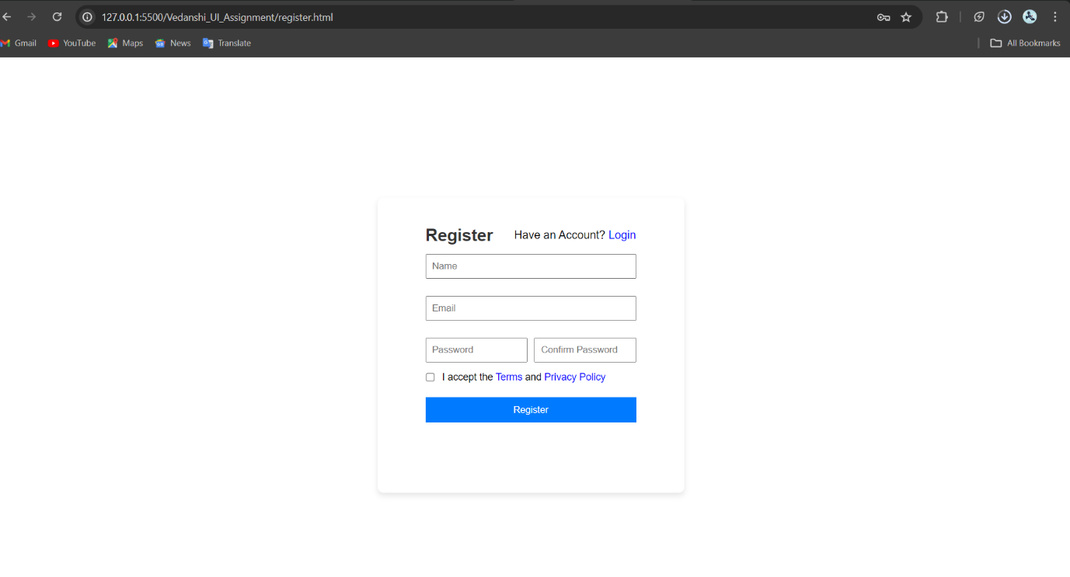

2)Login Page

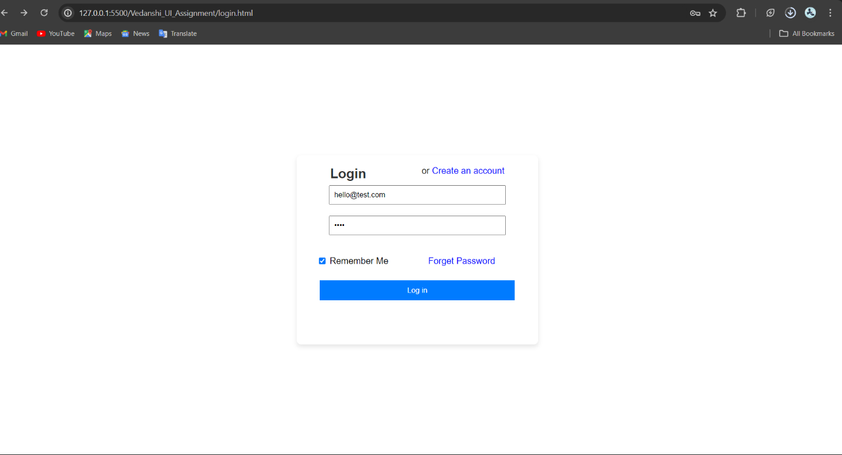

3)Forgot password page

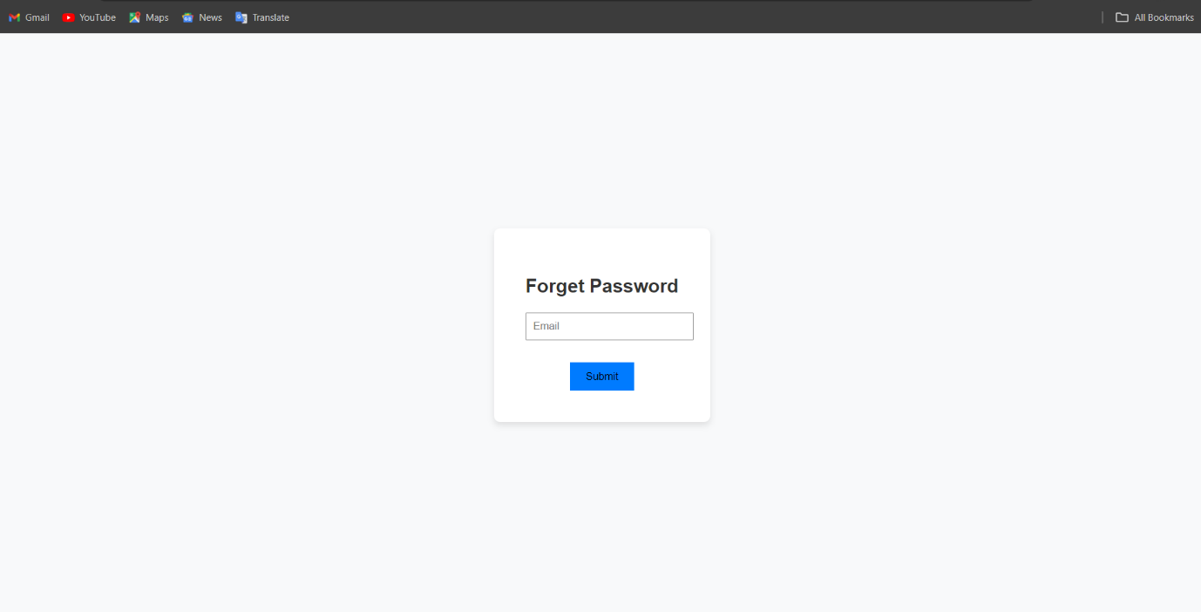

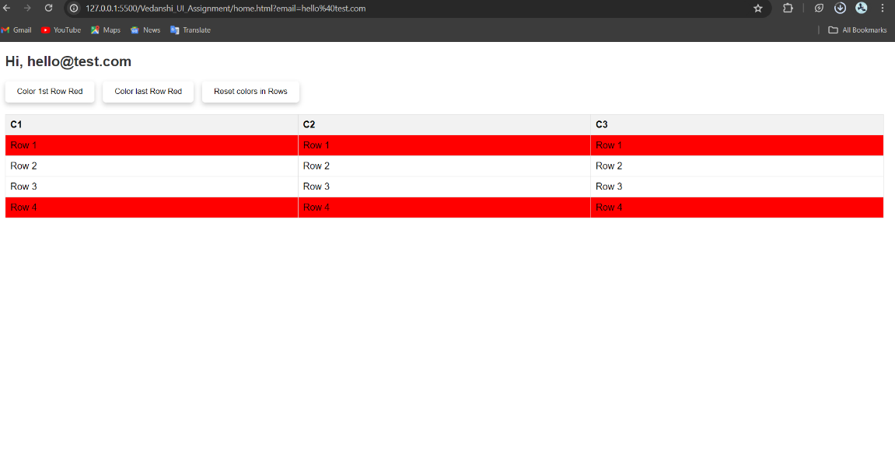

Home/table page ,Functioning of Buttons

